美語教師工作手冊
English Teacher’s Manual

【目錄Table of Contents】
- 前言 Preface
- 互動式三E教學法 Interactive 3E Teaching approach
- 教材介紹表 LiveABC English textbooks
- 教材配備表Checklist for teaching components
- 教師工作規範 Rules and regulations
- 教師考核 Teachers evaluation
附件一 教師應執行事項 Appendix 1: Checklist for teachers’ job duties
附件二 標準教學流程Appendix 2: Standardized Teaching Procedures
附件三 課程進度表Appendix 3: Class Syllabus
附件四 線上作業檢查表Appendix 4: Online HW Checklist
附件五 教案表格Appendix 5: Lesson plan
附件六 加強輔導紀錄表Appendix 6: Make up class form
附件七 期末成績單表格Appendix 7: Final report form
附件八 看課紀錄表Appendix 8 Class Observation Form
附件九 教師續班率紀錄表 Appendix 9 Record of return rate
附件十 教師年度受訓紀錄表
Appendix 10 Record of attendance for training courses
附件十一 教師參加會議及活動紀錄表
Appendix 11 Record of attendance for teachers’ meeting and important events

- 前言 Preface

LiveABC互動英語教學集團擁有最先進的IT技術與多媒體製作團隊，透過最專業的中外編輯人員，精心研發出各項“互動式英語多媒體學習產品”，為台灣數位學習的領導先驅。「LiveABC互動英語教學集團」現在將所有平面教材資源，結合多媒體網路互動教學，轉而落實在國人的美語教學上，因此創立了「Live互動美語」，將平面教材結合「LiveABC兒童英語網際學院」，創造虛實整合的學習新方式，開創在教學上革命性全新的教學模式，期能創造出數位化學習的效果，其說明分述如下：
- 教師上課數位化 (E-teaching)
老師在上課時利用「LiveABC兒童英語網際學院」做輔助教學，同樣的內容利用不同媒體表現出來，加深學習印象並提升學習興趣；同時也將傳統教具(如: 閃示卡)數位化。
- 學生學習數位化 (E-learning)
學生課前預習、課後複習以及線上功課，都可利用這個網站完成。
- 學校管理數位化 (E-management)
老師藉由後端的管理系統，可以了解所有學生的學習進度、學習狀況及學習成績，並和線上學生作即時通訊的提醒，學校老師也利用本網站與家長進行交流。

- 互動式3E教學法
Interactive 3E Teaching Approach
E-Teaching

Spiral approach 螺旋式教學
Situational approach 情境式教學
Communicative approach 溝通式教學
Interactive approach 互動式教學
(使用電子白板)

STUDENTS (以學生為本位)
become motivated 積極
proactive 主動
creative 創造
communicative 溝通

E-Learning E-Management

Placement test 線上分級測驗
Online evaluation 線上評量
E-Homework checking 線上功課檢閱
Learning record學習時數及排名紀錄
Instant Messenger線上叮嚀系統

Multimedia textbook series 多媒體教材系列
E-School兒童網際學院
E-Homework 線上功課
E-recording function 線上錄音功能
Online extension material 線上延伸學習內容

- 教材介紹 Introduction of LiveABC textbooks

主教材

Main textbooks
 | 適合年齡  Target Audience | 教材特色  Traits
Come to Live | age 6-12 | - 學習級數分明，內容循序漸進。  - 主題式情境教學，自然而然運用英文在生活中。  - 大量圖片輔助學習，利用真實圖片強化生活連結。  - 漸進式文法學習，螺旋式教學製造更多複習機會。  - 依循教學3P模式 (Presentation , Practice and Production)，鞏固學習基礎。  - 聽說讀寫並重，以phonics為基石奠定拼字及閱讀能力。  - 強化引導式寫作練習，具體的口說作業製造教室外的學習機會。  - 搭配網際學院及Live智慧點讀筆，學習方式全面升級。  This series is the most popular textbook at LiveABC. It offers not only printed materials but also the web school to enhance Ss’ learning performances.
Step up to Live | age 10-15 | - 學習級數與國中英語課綱平行，整合各家版本，超前學校進度。  - 細分每課文法點，孩子學習更扎實。  - 首創3E互動教學系統，輕鬆提升學習成效。  - 真人老師講解文法內容，孩子複習更輕鬆。  - 依循教學3P模式 (Presentation , Practice and Production)，鞏固學習基礎。  - 豐富且強大題庫系統，搭配國中常考的八大題型，強化孩子答題實力。  - 搭配網際學院，學習方式全面升級。  - 線上模擬大會考，累積實戰考試經驗。  This series is aimed for junior high school students. It’s grammar-based and there is a web school going with it.
Step up to Live Listening & Reading  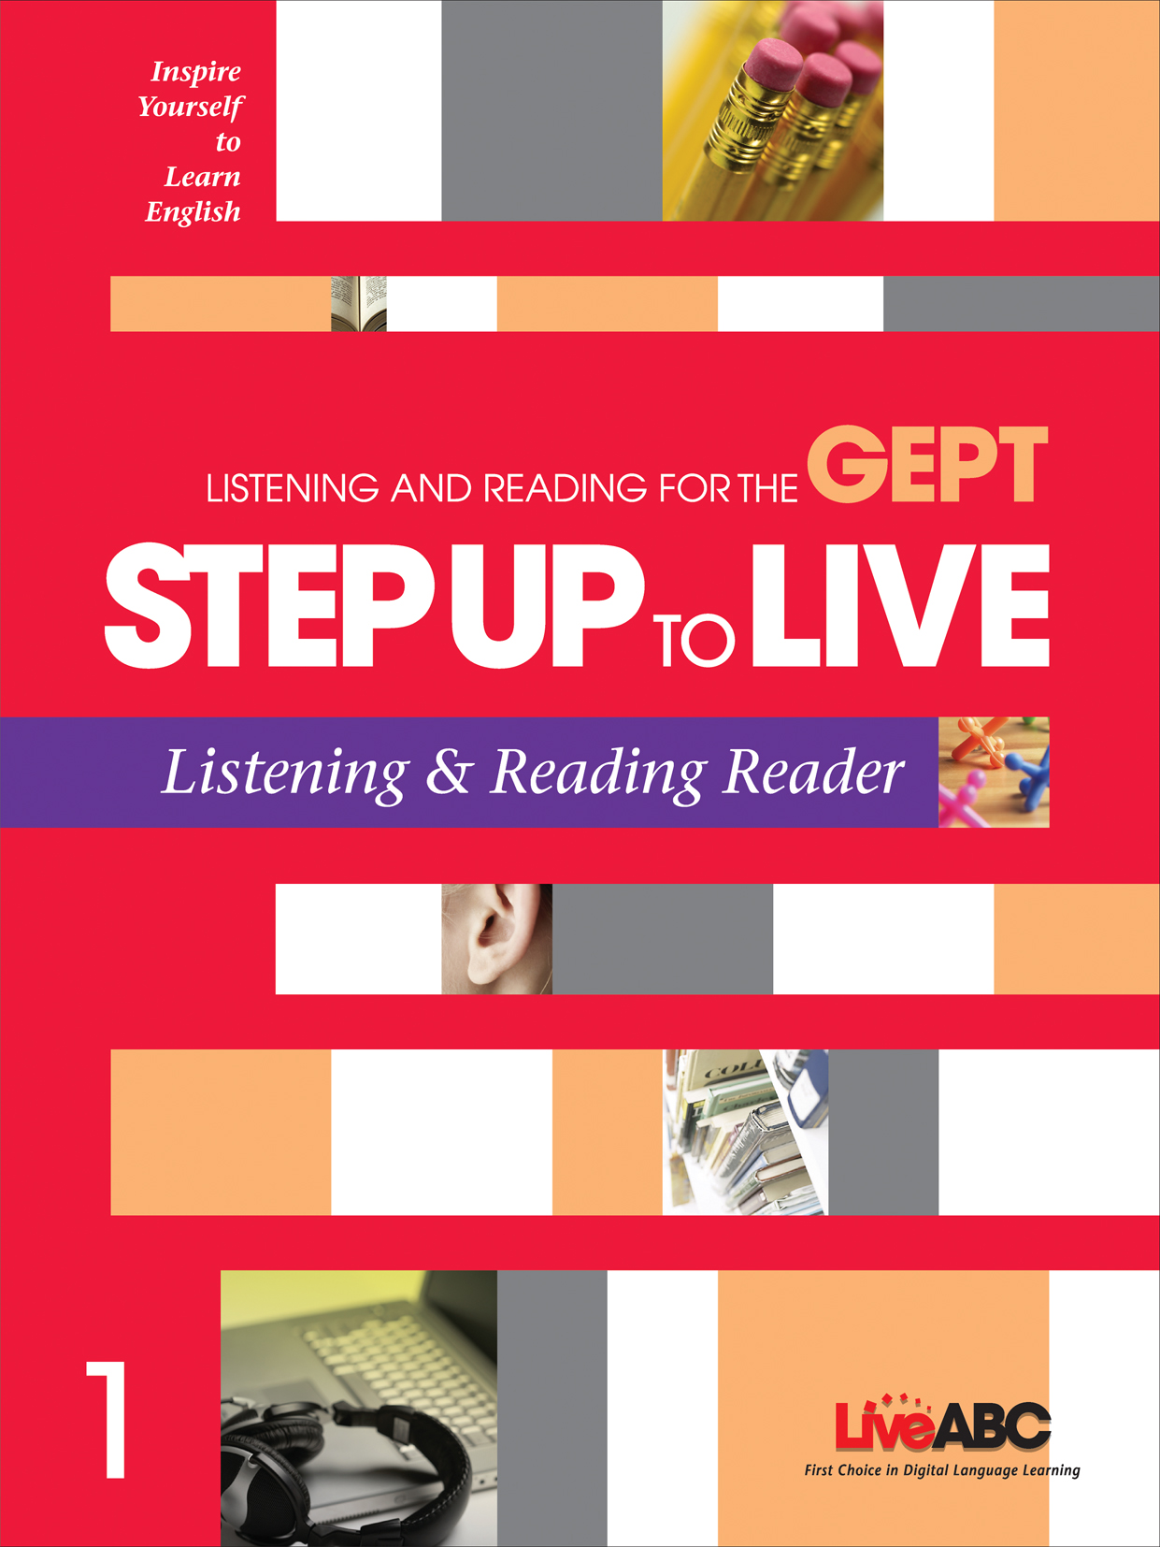 | age 10-15 | - 強化聽力閱讀能力，輔導孩子通過全民英檢。。  - 全民英檢仿真試題，累積考試實戰經驗。  - 依循教學3P模式 (Presentation , Practice and Production)，鞏固學習基礎。  - 豐富且強大題庫系統，強化孩子答題實力。  - 搭配英檢必勝學院，學習方式全面升級。  - 線上模擬英檢測驗，累積考試實戰經驗  - 線上英檢解題說明，於測驗後強化考試實力。  This series is for students who want to take GEPT elementary level.
國中文法解密  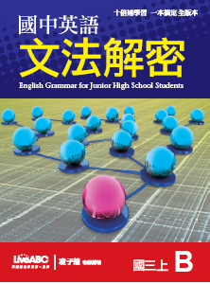 | age 10-15 | - 七個符號，解開英文翻譯的基因密碼(gene code)。  - 300個口訣，破解隱藏在詞類中的考題密碼。  - 將文法選擇、句子改寫、和翻譯等三大題型，編輯成冊，用最短的時間，作  最有效的練習。  - 模組化各類必考題型  - 超前進度，滾動式復習。  - 最佳英檢教材，和高中銜接教材，學習投資不重複。  - 強調以詞類與句型為核心的文法概念，克服文章閱讀障礙。

補充教材

Supplementary textbooks

 | 適合年齡  Target Audience |  | 教材特色  Traits
Sound it out  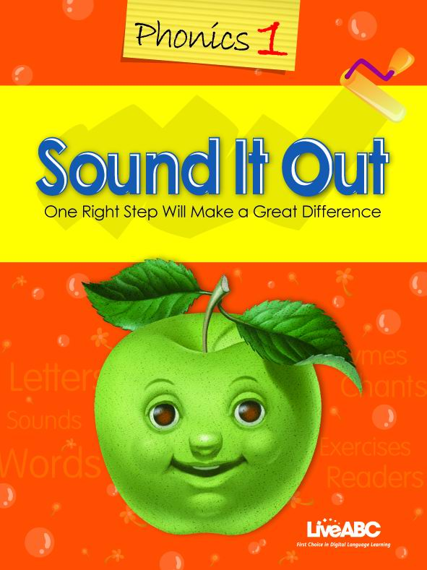 | age 6-12 |  | This series is for phonics learning. It follows the theory of linguistics and offers lots of phonics exercises in the book.
Cambridge course  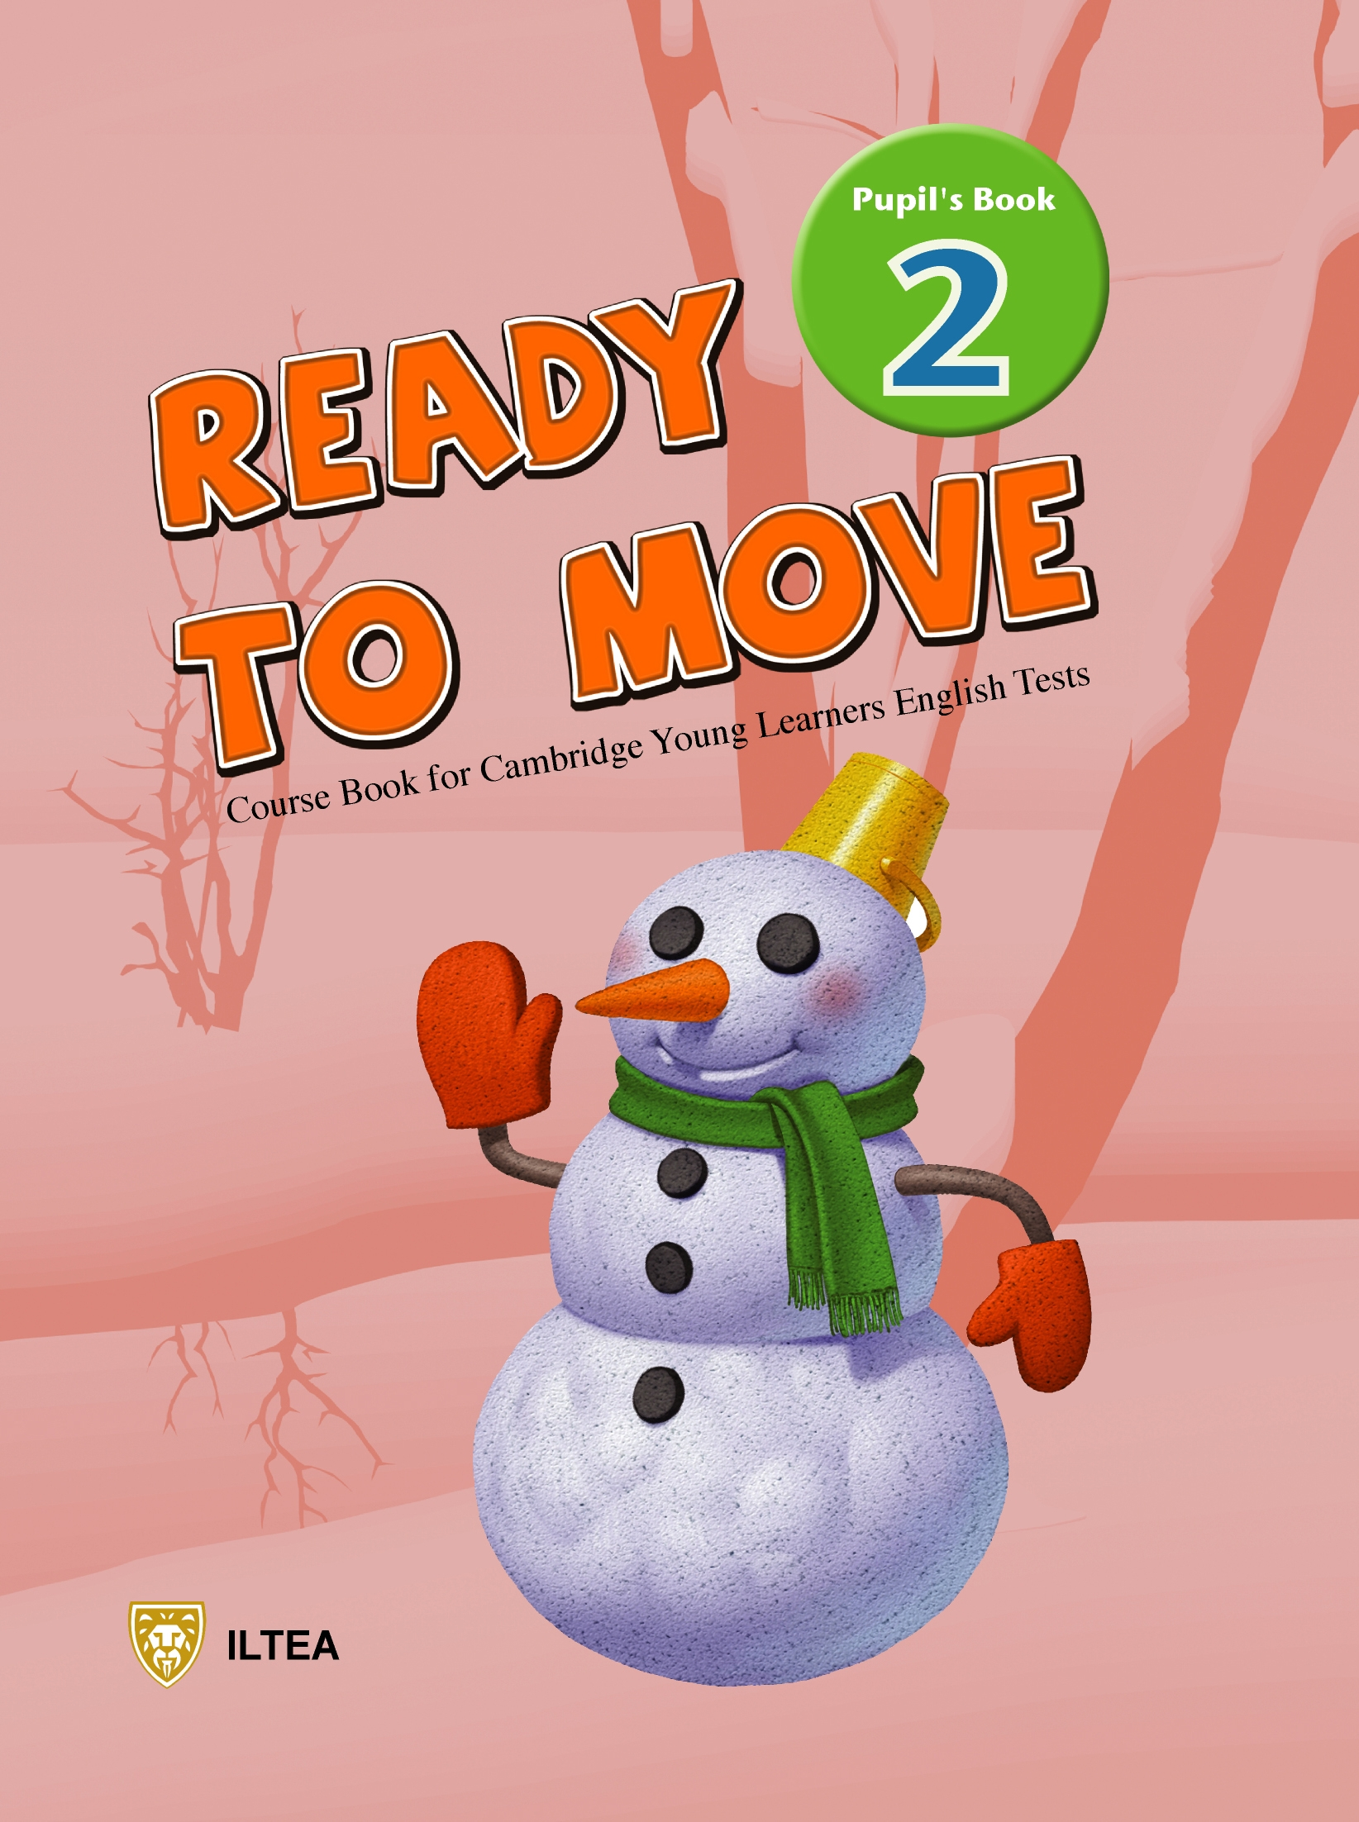 | age 6-16 |  | We cooperated with YLE and this series of books is aimed for the students who want to take Cambridge exams.
LiveABC Reader’s theater  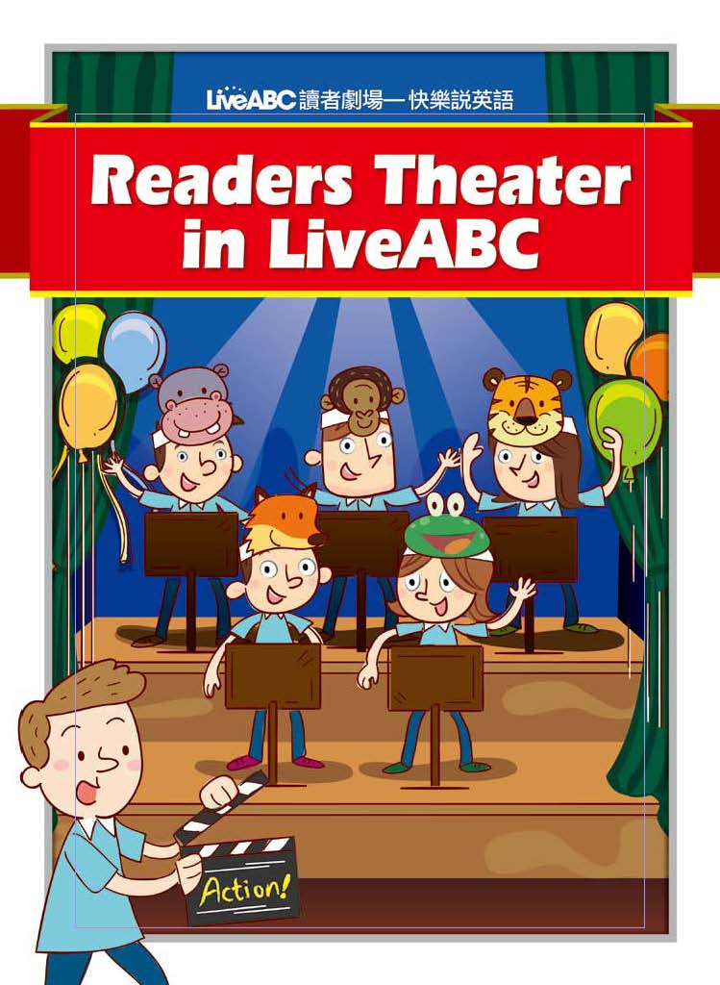 | age 6-12 |  | It combines 4 skills (listening, speaking, reading and writing) in one book and helps Ss speak English fluently and read English smoothly.
- 教材配備表 Checklist for teaching components
Textbook  Components | Come to live | Sound it out | Step up to Live | Step up to Live Listening & Reading | 國中文法解密 | LiveABC Reader’s theater
Student’s Book | ✓ | ✓ | ✓ | ✓ | ✓ | ✓
Workbooks | ✓ |  | ✓ | ✓
Audio CDs | ✓ | ✓ | ✓ | ✓ |  | ✓
Readers | ✓  (B1~8)
Reading and Writing Practice Book | ✓  (B9~12)
Syllabus  (Please refer to Teacher’s resources on web school) | ✓ |  | ✓ | ✓ | ✓
Teacher’s Guide  (Please refer to Teacher’s resources on web school) | ✓ |  |  |  | ✓
Web school  (CTL: kids.liveabc.com)  (STUP: junior.liveabc.com) | ✓ |  | ✓
Flashcards | ✓  (starter~B8) | ✓
Workbook PPT  (Please refer to Teacher’s resources on web school) | ✓
Online HW  (Please refer to web school) | ✓
Test sheets  (Please refer to Teacher’s resources on web school) | ✓
Test bank | ✓ |  | ✓
Live pen | ✓
Placement Test | ✓ |  |  | ✓
Anglia Exam | ✓ |  | ✓ | ✓ | ✓

五、教師工作規範 Rules and regulations
- 訓練 Training
- 每位教師於開始上課前必須按規定至校實習數位化教學2-3堂課，並接受總公司所舉辦之職前訓練，如情況特殊，得由各班內教學組長或資深之全職教師做初級職前訓練。
Before employment commences, all teachers should complete a 2–hour training class provided by the Head Office of LiveABC and a 4 – hour observation. In some cases, the training can be conducted by the supervisor or a senior full-time teacher at one of the schools.
- 依實際需要，必須接受總公司之在職訓練，每半年度至少上2次課程 (一次課程為三小時)，美語教學組長以上等級 (含教務主任)，每半年度至少上4次課程 (一次課程為三小時)，不得因故缺課。
Teachers should receive monthly professional training (at least two different classes per half year) provided by the Head Office of LiveABC. Head English teacher or Academic supervisor should receive monthly professional training (at least four different classes per half year) provided by the Head Office of LiveABC.
- 教師受訓次數將直接影響個人表現績效及考核結果。
The attendance of Teacher’s training will directly influence each teacher’s performances and the outcome of teacher’s evaluation as well.

2. 教學 Teaching
- 每位教師必須依照教學進度表上之進度教學。
Every teacher should follow the syllabus.
- 在適合等級之學習課程中，教師必須規定一些句型習寫或寫作(高階)的作業讓學生於筆記本上 (Writing Book)完成。
Teachers should assign writing practice to the students that should be written down in the Writing Books.
- 上課儘量使用全美語教學。
Use English as much as possible while teaching.
- 課外教材之補充，必須符合課程內容，禁讓學生看與課程無關的影片或網站，且應將所補充之教材內容完整的寫在教師日誌內。
All supplementary materials need to be relevant to the course. Teachers have to specify the details of the supplementary materials in the Teacher’s Diary.
- 使用補充教材前，需事先告知並詢問教學主任，可由資源庫裡尋找相關資料。
Before preparing the supplementary material, it is strongly recommended to ask the academic supervisor for more resources. The supervisor will assist you in finding the material in the Live ABC resource bank.
- 不得擅自對外使用LiveABC之教材，或於授課時間內備課。
Outside use of LiveABC material will result in termination from employment and the preparation of other classes during teaching time is strongly prohibited.
- 每堂課上課或下課前應照進度表給予學生單字小考及家庭作業。
The appropriate quiz and homework should be assigned according to the curriculum progress every class.
- 學生每次上課時，必須繳交作業，請確實批改並給予訂正，單字及句子皆訂正3遍。下課前或下次上課時交還給學生。
Teachers correct students’ homework every class and they should ask students to correct mistakes in the workbooks
- 請充分利用試題光碟，每次上課應有一次平時考，每unit學完後，有一次週考，每月有月評量及每學期末晉級評量，考試內容必須包含口試及筆試，考試題目由教研部製作，也可由教師自行修改命題。
Every class, teachers should give students a quiz. After teaching one unit, the teacher should give the students a weekly quiz (test sheet required). Monthly tests and a proficiency test will be held within each term. Please note that we have a test bank disk for you to use.
- 每位教師皆須將平時測驗、週考，月評量、晉級評量等之成績登記於點名表後之成績欄中，並請確實執行。
The teacher should check students’ attendance each class and write down students’ scores in the class folder.
- 必配合教學Demo、PTA及聖誕節成果發表會等大型活動。
Cooperation in teaching demonstration, PTA meetings and Xmas is required.
(12) 教師必須與家長保持溝通，特別是學生表現異常時。家長有任何抱怨或建議事項時，須馬上告知班主任或教務主任。
Teachers are required to communicate with parents, especially when students don’t perform well. Any complaints, troubles or suggestions concerning student’s learning from the part of the parents or the students should be reported immediately to the director of the school.

(13) 教學主任看課或有外賓參觀時有權不事先告知教師。

Advance notice is not required before observing a teacher’s class or when guests visiting the school.
3. 課後工作說明及執行技巧 After Class Duties
(1) 家庭作業批改(Homework correction)
- 可利用教師資源中的作業本PPT作講解，或於當日下課前，針對本次作業作說明，方便學生掌握練習。
The teacher can use workbook PPT (which can be downloaded from the web school) to explain the common mistakes seen from students’ answers.
p.s. You can download workbook PPT in the section of teacher’s resources from the web school.
- 明確指出錯誤部份。
Accurately point out the mistakes in the workbook.
- 確實要求學生訂正。
Ask students to correct their workbooks.
- 批閱後請簽名並加註成績及日期。
Put the grade, date and teacher’s signature in the students’ workbooks.
- 統整學生錯誤，並於下次上課，再一次講解。
Review material that students are commonly having difficulty with.
(2) 考卷批改 (Test sheet correction)
- 確實要求學生訂正。
Ask students to correct the mistakes on their test.
- 於訂正後請家長簽名，於下次上課檢查。
After students are done correcting their test, have their parents sign them.
- 對分數過低的學生給多輔導。
Arrange a make-up class for the students who get under 80% on their test.
- 統整學生錯誤，並於下次上課，再一次講解。
Review materials that students are commonly having difficulty with.
(3) 週考 Weekly Quiz

老師應於每週完成學生該unit之評量。學生成績若低於80分，請務必為孩子做課後加強輔導。

Arrange a make-up class for students who get under 80% on their weekly quiz.

(4) 月評量 Monthly Test

老師應於每月月底完成學生之月評量。學生成績若低於80分，請務必為孩子做課後加強輔導。

Arrange a make-up class for the students who get under 80% on their monthly test.

(5) 晉級考試 Proficiency Test

老師應於每學期結束前完成學生的晉級評量。學生成績若低於80分，請與教學主任溝通 :

If any students’ final grade is under 80%, teachers must discuss the following with the academic supervisor:
- 是否要讓學生降級重讀

Whether the students should repeat the level
- 老師應調整教學方式

Whether the teacher should adjust their teaching methods
- 啟動補救教學

Whether to schedule make up or extra classes
(6) 期末成績單Final Report
教師須於學期結束後製作成績單及於升級証書上簽名，成績單中需包含學生表現評比及評語。
The teacher must prepare a final report and a Certificate of Completion at the end of the semester. The student’s grades and the teachers’ comment should be included in the final report.

(7) 成果發表會 Performance Day / 親師座談會 PTA

老師應配合校內成果發表會及親師座談會。
Teachers need to attend the PTA meetings or Performance Days of the class. They will get half hour pay for attending these events.
4. 行政要求 Administrative Requirement
- 每兩週將召開教師會議，請務必參加。除討論各班狀況，網站新功能宣達及行政事項傳達之外，每位教師皆會輪流在會議中做簡短Demo。總公司教學總督導也將每月固定與教務主任開會，討論各校及各老師狀況，及宣達公司教學新政策等。
A regular teacher’s meeting will be held every two weeks. Each teacher will be asked to take turns doing a brief demo in the meeting. As for academic supervisors, a monthly meeting will be held by the Chief academic supervisor at the head office. Issues regarding schools, teachers will be discussed in the regular meeting.
- 作業本：每位學生我們會發給A、B二本作業本，每次上課前學生應將作業簿交給教師，教師應規定作業並按時批改。倘若有作業未完成學生，請務必並告知班主任及其家長，利用下課或放學留下來完成，或請學生擇期補寫。
Workbooks: We provide each student with two workbooks per term. Teachers should correct the students’ homework every class. Please notify school directors and parents of those who don’t hand in homework. Students who don’t finish their homework have to make it up during break time or after class.
- 線上作業:每週由教務或相關人員上網查詢線上作業(e-homework)完成狀況，未達三個皇冠或未完成者請老師督促完成。
E-homework: Teachers should check e-homework checklist in the class folder from time to time and remind students who didn’t finish their e-homework every class.
(4) 聯絡簿：每次上課前學生應將聯絡簿交給教師，老師統一收齊後交由櫃檯，若學生家長有任何意見，將由班主任或行政人員回覆。老師下課前應將聯絡簿填寫評語完畢交由學生帶回。
Communication book: Before each class, students should hand in the communication book. Teachers should give the communication books to the front desk. The school director will reply to the comments left by parents. Before the end of the class, teachers should sign the communication book and write down students’ learning progress in it.
- 確實完成班級檔案資料夾 (內應有 (1) 教師應執行事項checklist、(2) 教學標準流 程、(3) syllabus、(4) 線上作業檢查表、(5) 點名表、(6) 成績登記表、(7) 教案表格、(8) 加強輔導紀錄表及 (9 )期末成績單，(10)黑、藍、紅麥克筆共三支，及相關教師用書)，並將學生測驗卷、學習單、補充資料、戶外教學及節慶教學資料等等歸入學生成長手冊。
Complete the class folder on time. The folder should include (1) Class routines checklist (2) Standardized teaching procedures (3) Syllabus (4) Online Homework checklist (5) Roll call sheet (6) Quiz record sheet (7) Lesson plan (8) Make-up class form (9) Final report (10) Markers and Teachers’ books. Put students’ worksheets, supplementary materials or activity sheets in the Students’ portfolios.
- 教學教具使用完畢後，請按分類歸回原位。並清理教師使用檯面，保持電腦螢幕之清潔。下課後，須關閉冷氣、電燈投影設備，方可離開。
After using teaching props, please put them back in their place. Remember to clean up the table and turn off the computer after class. Remember to turn off the AC, lights and the projector after you finish the class.
(7) 教師須著合適的衣著到校上課，男女教師禁穿無袖背心或細肩帶背心，褲長及裙長應及膝，不宜過短。
A professional appearance is required and it will assist you in gaining respect and cooperation from both the students and parents.
(8) 如遇連續假期、彈性放假等，皆由行政部門宣佈放假與否，勿自行對
學生宣佈。
Do not announce anything about classes which must be postponed or cancelled due to holidays or some other reason to the students. The front desk will send out an official announcement.
(9) 學生如因特殊理由欲更改上課時段時，請與行政人員溝通並申請辦理。
If a student needs to change his/her class time for any reason, the teacher should notify the school supervisor.
(10) 教師之地址或電話變更時，應隨時告知行政人員，以利聯繫。
In order to facilitate communication, all changes to teachers’ telephone numbers and addresses should be reported to the front desk.
(11) 班級人數低於成本時，班內有權解散或合併該班。
When there are not enough students enrolled in a class, the school has the right to decide whether or not the class should be dismissed or combined with another class.
(12) 如發覺有設施及任何公共設備或環境遭學生破壞、污損，應立即追究
查明。
Any damage to school facilities, assets or environment by students should be reported and inspected.
(13) 嚴禁相互討論或探聽他人薪資，違者嚴懲，重則革職。
Discussing salary / hourly pay with coworkers is strictly prohibited.

六、美語教師考核 Teachers’ and Supervisors’ Evaluation
◆ 考核時間點 (Time): 每年2/1~隔年1/31
◆ 考核作業期間: 2/1~2/20
◆ 薪資調整開始日期: 每年3/1
◆ 考核人員(Assessors): 班主任 / 教務主任 / 教務組長
(School director / Academic supervisor /Head English Teacher)
◆ 考核向度 (Aspects):
- 教師教學品質及教學能力: 30%
Teaching quality and teacher’s competency: 30%
- 敎師教學成效展現 (續班率調查、檢定考成績等): 30%
Teaching performances (Return rate, test scores and etc): 30%
- 教師教育訓練、會議及活動參與狀況: 15%
Attendance of teacher training courses, meetings and important events: 15%
- 教學工作態度: 25%
Work attitude: 25%
- 考核結果將成為升遷及加薪的依據
The range of the pay raise will be determined by the teachers’ evaluation result.

七、教務主任考核 Supervisors’ Evaluation
◆ 考核時間點 (Time): 每年2/1~隔年1/31
◆ 考核作業期間: 2/1~2/20
◆ 薪資調整開始日期: 每年3/1
◆ 考核人員(Assessors): 班主任 (School directors)
◆ 考核向度 (Aspects):
1. 教師教學品質及教學能力: 20%
Teaching quality and teacher’s competency: 20%
2. 敎師教學成效展現 (續班率調查、檢定考成績等): 20%
Teaching performances (Return rate, test scores and etc): 20%
3. 教師教育訓練、會議及活動參與狀況: 15%
Attendance of teacher training courses, meetings and important events: 15%
4. 教學工作態度: 15%
Work attitude: 15%
5. 管理能力展現: 30%
Management ability: 30%
- 考核結果將成為升遷及加薪的依據
The range of the pay raise will be determined by the teachers’ evaluation result.

教師考核總表Overall Evaluation for English Teachers

敎師姓名(Teacher’s name): __________________

考核期間 (Evaluation Period): ______________________
考核向度 | 分數 | 評語

教師教學品質及教學能力

Teaching quality and teacher’s competency (30%)

使用美語教學比例、課室用語使用、教具使用、多媒體使用、看課表現、師生關係等

考核來源: 看課紀錄表 (Class Observation Form) - appendix 8

敎師教學成效展現 (續班率調查、檢定考成績等) Teaching performances (Return rate, test scores and etc) (30%)

安格檢定考、月評量及晉級評量平均分數、續班率、作業訂正等

考核來源: 教師續班率紀錄表 (Record of return rate)- appendix 9

教師教育訓練、會議及活動參與狀況(15%)

參加師訓次數、教師會議及大型活動等

考核來源: 教師受訓紀錄表 (Attendance of teacher training courses) - appendix 10、教師參與會議及活動紀錄表 (Attendance of teachers’ meetings and important events)- appendix 11

敎師工作態度 (25%)

出缺勤: 有無登錄作業及考試成績、有效跟家長溝通、反應學習狀況、課前（後）輔導落後學生

考核來源: 打卡紀錄 Attendance card

總分 Total Score

主任總評 Overall evaluation

分校班主任 | 教學督導 | 文教事業處協理

教務主任考核總表Overall Evaluation for Academic Supervisors

姓名(name): __________________

考核期間 (Evaluation Period): ______________________
考核向度 | 分數 | 評語

教師教學品質及教學能力

Teaching quality and teacher’s competency (20%)

使用美語教學比例、課室用語使用、教具使用、多媒體使用、看課表現、師生關係等

考核來源: 看課紀錄表 (Class Observation Form) - appendix 8

敎師教學成效展現 (續班率調查、檢定考成績等) Teaching performances (Return rate, test scores and etc) (20%)

安格檢定考、月評量及晉級評量平均分數、續班率、作業訂正等

考核來源: 教師續班率紀錄表 (Record of return rate)- appendix 9

教師教育訓練、會議及活動參與狀況(15%)

參加師訓次數、教師會議及大型活動等

考核來源: 教師受訓紀錄表 (Attendance of teacher training courses) - appendix 10、教師參與會議及活動紀錄表 (Attendance of teachers’ meetings and important events)- appendix 11

敎師工作態度 (15%)

出缺勤: (10%)、有無登錄作業及考試成績、有效跟家長溝通、反應學習狀況、課前（後）輔導落後學生 (5%)

考核來源: 打卡紀錄 Attendance card

管理能力展現 (30%)

總分 Total Score

主任總評 Overall evaluation

分校班主任 | 教學督導 | 文教事業處協理
附件一: 敎師應執行事項checklist
Appendix 1: checklist for teachers’ job duties

項目 | 每次  Every class | 每週  Every week | 每兩週  Every two weeks | 每月  Every month | 升級前  Before Ss go to next level
教案撰寫  Write up lesson plans | ✓
點名  Roll call | ✓
批改作業及聯絡簿  Correct homework and sign communication book | ✓
單字小考  Class quiz | ✓
週考  Weekly quiz |  | ✓
月評量  Monthly test |  |  |  | ✓
晉級考  Proficiency test |  |  |  |  | ✓
關電腦、冷氣等  Turn off computers and AC | ✓
寫期末成績單及證書  Finish final report and certificate |  |  |  |  | ✓
參加教務會議  Attend teacher’s meeting |  |  | ✓

附件二: Live互動美語 標準教學流程

Appendix 2: Live Interactive English Standardized Teaching Procedures
 | 步驟Steps | 工作內容Duty specification
課前備課 Before Class | 拿班級檔案夾  Take Class File Folder | 確定今日上課進度/課程內容/是否有考試。  Confirmation of course content for the day, to see if there’re any quizzes or tests, etc.
課前備課 Before Class | 備課  Design Lesson plan | 撰寫教案，查看班級檔案夾是否有co-teacher 或是教務主任留的訊息。  Write up lesson plans and check the class folder to see if there are any comments made by your co-teacher or the supervisor
課前備課 Before Class | 準備上課器材  Prepare teaching materials | 準備教具、生字卡、學習單等。  Prepare of teaching materials, props, flashcards, etc.
課前備課 Before Class | 行政溝通事項  Communicate with administrative counter | 是否有預告事項、通知單。  Check with the counter to see if there are any special announcements to make, any notice letters to be distributed, etc.
課中 In Class (Please finish these steps within 10 minutes) | 學生抄聯絡簿  Communication Book | 將今日上課進度抄在黑板上。  Copy today’s class outline on the board
課中 In Class (Please finish these steps within 10 minutes) | 點收今日應交作業  Check and collect Homework | 了解未交作業學生名單及詳細情形。  If anyone has failed to hand in their homework, find out why
課中 In Class (Please finish these steps within 10 minutes) | 點名  Roll call | 將未到名單送到櫃檯，確定學生是否請假。  Notify the administrative counter of all absent students
課中 In Class (Please finish these steps within 10 minutes) | 開始進入今日課程  Start Today’s lesson | 前面三項動作盡量在10分鐘內做完。  It is recommended that the three previous steps are finished within ten minutes
休息 Break  (10 minutes) | 簽聯絡簿、批改小考  Communication Book and Quiz | 批改小考，並登錄學生情況或預告事項於聯絡簿上。  Sign communication books and correct students’ quizzes
休息 Break  (10 minutes) | 發回前次作業簿  Return previous homework assignments | 叮囑學生訂正錯誤，輔導錯誤較多學生，補收上次作業。  Remind students to correct any mistakes that they’ve made
課後管理 After class | 發回聯絡簿或寫作本  Return communication book and writing book | 口頭提醒今日回家作業  Remind students what today’s homework is
課後管理 After class | 總複習今天課程  Wrap up | 檢測今日上課重點  Do a final wrap up
課後管理 After class | 待處理學生事宜  Arrange make up classes | 繳交功課未完成、小考需補考或需加強輔導名單。  Hand in the list of students who didn’t finish homework, who failed the quiz, who missed the quiz or who need to make up the class to the supervisor
課後管理 After class | 離開教室前  Before leaving the classroom | 將教室課桌椅還原、清潔、關電燈、冷氣、電腦及投影機。  Put the chairs and the desks back in place, pick up the trash and turn off the PC, Projector, AC and the lights
課後管理 After class | 離開學校前  Before leaving the classroom | 填寫班級檔案夾，並將所有教具檔案，歸回原位、打卡。  Leave any notes for your co-teacher, return all teaching materials and files, clock out before you leave
備註 remarks | 教師需立即回報學生狀況給教務主任 如功課未完成者、小考不及格者、上課不專心吵鬧者。  Teachers should report students’ learning performance to the supervisor,  including those who didn’t finish their homework, those who failed the  quizzes, or those who misbehaved in class.
課中互動建議流程 Suggested teaching procedures

First Hour |  | Second Hour
Warm-up & Roll call  點名 / 抄寫聯絡本 / 暖身 | 5-10 mins | Go over quiz / Review Hour 1 teaching content  檢討考卷 / 複習Hour 1內容 | 10 mins
Teaching Procedures  Presentation: T uses the web school to do class presentation (利用網校呈現本課內容)  Practice: T provides some drill practice or activities to Ss (學生練習)  Production: T checks Ss’ production through games and activities (以遊戲或活動檢測孩子成果輸出) | 30-35 mins | Teaching Procedures  Presentation: T uses the web school to do class presentation (利用網校呈現本課內容)  Practice: T provides some drill practice or activities to Ss (學生練習)  Production: T checks Ss’ production through games and activities (以遊戲或活動檢測孩子成果輸出) | 20 mins
Quiz  小考 | 10 mins | Writing practice  寫作練習 | 10 mins
Break time  批改聯絡本及小考本 / 學生休息 | 10 mins | Wrap-up  總複習/單字背誦 | 10 mins

附件三: 課程進度表
Appendix 3: Class syllabus
(Please download the correct level of the class syllabus from the web school)

Book 1 Syllabus (Fourth Edition)

Date |  | IRS / Quiz/Exam | CTL SB | CTL Reader | Workbook | Online HW | Recording Assignments | Writing  Practices
1 |  |  | U.1-1  p. 8-11 |  | (A) p. 2-3
2 |  |  | U.1-2  p. 12-15 |  | (B) p. 2-3 | Part A, B | WB (B) p.3 Part G
3 |  | IRS / Weekly quiz | Review U.1 |  | (A) p. 4-5 | Part C, D
4 |  |  | U.2-1  p. 16-19 |  | (B) p. 4-5
5 |  |  | U.2-2  p. 20-23 |  | (A) p. 6-7 | Part A, B | WB (A) p.6 Part E
6 |  | IRS / Weekly quiz | Review U.2 |  | (B) p. 6-7 | Part C, D
7 |  |  | U.3-1  p. 24-27 | p.2 | (A) p. 8-9
8 |  |  | U.3-2  p. 28-31 | p.3 | (B) p. 8-9 | Part A, B
9 |  | IRS / Weekly quiz | Review U.3 | p.2-3 | (A) p.10-11 | Part C, D | WB (A) p.11 Part K
10 |  | Monthly test 1 (U.1~3) | Review 1  p. 32-33 | p.4 | (B) p. 10-13
11 |  |  | U.4-1  p. 34-37 | p.3~4 | (A) p.12-13 |  | WB (A) p.13 Part D
12 |  |  | U.4-2  p. 38-41 | p.1~4 | (B) p.14-15 | Part A, B |  | A
13 |  | IRS / Weekly quiz | Review U.4 | p.5 | (A) p.14-15 | Part C, D
14 |  |  | U.5-1  p. 42-45 | p.6 | (B) p.16-17
15 |  |  | U.5-2  p. 46-49 | p.5~6 | (A) p.16-17 | Part A, B | WB (A) p.17 Part G
16 |  | IRS / Weekly quiz | Review U.5 | p.7 | (B) p.18-19 | Part C, D
17 |  |  | U.6-1  p. 50-53 | P.8 | (A) p.18-19
18 |  |  | U.6-2  p. 54-57 | p.7~8 | (B) p.20-21 | Part A, B | WB (B) p.21  Part F
19 |  | IRS / Weekly quiz | Review U.6 | p.5~8 | (A) p.20-21 | Part C, D
20 |  | Monthly test 2 (U.4~6) | Review 2  p. 58-59 | p.9 | (B) p.22-25
21 |  |  | U.7-1  p. 60-63 | p.10 | (A) p.22-23 |  |  | B
22 |  |  | U.7-2  p. 64-67 | p. 9~10 | (B) p.26-27 | Part A, B | WB (B) P.27  Part G
23 |  | IRS / Weekly quiz | Review U7 | p.11 | (A) p.24-25 | Part C, D
24 |  |  | U.8-1  p. 68-71 | p.12 | (B) p.28-29
25 |  |  | U.8-2  p. 72-75 | p. 11~12 | (A) p.26-27 | Part A, B | WB (A) p.26 Part E
26 |  | IRS / Weekly quiz | Review U8 | p. 9~12 | (B) p.30-31 | Part C, D
27 |  |  | U.9-1  p. 76-79 | p.13 | (A) p.28-29
28 |  |  | U.9-2  p. 80-83 | p.1~13 | (B) p.32-33 | Part A, B | WB (B) p.33 Part G
29 |  | IRS / Weekly quiz | Review U9 | p.14 | (A) p.30-31 | Part C, D
30 |  | Monthly test 3 (U.7~9) | Review 3  p. 84-85 | p.15 | (B) p.34-37
31 |  | Proficiency test (U.1~9) | Review |  | (B) p.38-39
32 |  |  | Review |  |  |  |  | C

附件四: 線上作業檢查表
Appendix 4: Online HW Checklist

Online Homework Checklist
Name |  | A | B | C | D | Name |  | A | B | C | D
 | Unit 1 |  |  |  |  |  | Unit 1
 | Unit 2 |  |  |  |  |  | Unit 2
 | Unit 3 |  |  |  |  |  | Unit 3
 | Unit 4 |  |  |  |  |  | Unit 4
 | Unit 5 |  |  |  |  |  | Unit 5
 | Unit 6 |  |  |  |  |  | Unit 6
 | Unit 7 |  |  |  |  |  | Unit 7
 | Unit 8 |  |  |  |  |  | Unit 8
 | Unit 9 |  |  |  |  |  | Unit 9
 | Unit 1 |  |  |  |  |  | Unit 1
 | Unit 2 |  |  |  |  |  | Unit 2
 | Unit 3 |  |  |  |  |  | Unit 3
 | Unit 4 |  |  |  |  |  | Unit 4
 | Unit 5 |  |  |  |  |  | Unit 5
 | Unit 6 |  |  |  |  |  | Unit 6
 | Unit 7 |  |  |  |  |  | Unit 7
 | Unit 8 |  |  |  |  |  | Unit 8
 | Unit 9 |  |  |  |  |  | Unit 9
 | Unit 1 |  |  |  |  |  | Unit 1
 | Unit 2 |  |  |  |  |  | Unit 2
 | Unit 3 |  |  |  |  |  | Unit 3
 | Unit 4 |  |  |  |  |  | Unit 4
 | Unit 5 |  |  |  |  |  | Unit 5
 | Unit 6 |  |  |  |  |  | Unit 6
 | Unit 7 |  |  |  |  |  | Unit 7
 | Unit 8 |  |  |  |  |  | Unit 8
 | Unit 9 |  |  |  |  |  | Unit 9

附件五Appendix 5: 教案表格Lesson plan

Outline
Textbook:
Vocabulary:
Sentence Pattern:
Phonics:
Supplementary material:
Props:
Teaching Procedures
Hour 1
Hour 2
Homework assignment
◆ Notes to your co-teacher

附件六: 加強輔導紀錄表

Appendix 6: Make up class form

加強輔導記錄表
Make up class form

分校  School |  | 輔導級數  Level |  |  | 加強輔導日期  Date
班級  Class |  | 輔導級數  Level
教師姓名  Teacher’s name |  | 輔導級數  Level |  |  | 加強輔導時間  Time
加強輔導  學生  Student’s name |  | 輔導級數  Level
加強輔導原因  Reason for a make up class | □缺課 (Absence) □進度落後 (Weak performance)  □作業未完成 (Didn’t complete HW)  □其他 (Others)：
輔導要項摘記  notes | 輔導過程及成效紀錄  make up class report |  |  | 備註 Remarks
主任簽名
Director’s signature:

Notes: After you’re done with a make-up class, please fill out this form and put it in Ss’ communication book.

附件七: 期末成績單表格

Appendix 7: Final report

Final Report 期末評量報告

Name: _____ Class: _______ Period:
2009
2009

(1) Ordinary Grade Report 平時成績報告 (50%) |  |  |  |  |  |  | (2) Monthly Test Grade Report 月考成績報告(20%)
Quizzes  小考評量  (20%) | % |  | Homework  作業評量(20%) | % | Online HW  線上作業  評量  (10%) | % | Monthly Test  月考評量  (20%) |  | %  (原始成績: / / )
(3) Final Exam Grade Report 期末考成績報告 (30%)
Listening & Speaking  聽力與口語  (15%) |  | %  (原始成績: ) |  |  | Reading & Writing  閱讀與寫作  (15%) |  |  | %  (原始成績: )
(1) + (2) + (3) = %  (Total Grade Report 總評量成績) |  |  |  |  | □ Passed 通過 □ Not Passed 未通過  Suggestion 建議：
Attendance Record 出席紀錄
Total Classes 總堂數： __
□ Full Attendance 全勤 □ Absent 缺席： Class(es)

Teacher’s Comments 教師評語
Listening Ability  聽力能力 | □Excellent 很棒 □Good 佳 □Fair 尚可 □Needs Improvement 待加強
Speaking Ability  口語能力 | □Excellent 很棒 □ Good佳 □Fair 尚可 □Needs Improvement 待加強
Reading Ability  閱讀能力 | □Excellent 很棒 □ Good佳 □Fair 尚可 □Needs Improvement 待加強
Writing Ability  寫作能力 | □Excellent 很棒 □ Good佳 □Fair 尚可 □Needs Improvement 待加強
Teachers’ Comments 教師評語
Teacher’s Signature
教師簽名

_____________________
Director’s Signature
教學主管簽名

___________________
Parents’ Signature
家長簽名

_______________________

附件八: 看課紀錄表 Class Observation Form
看課記錄表
Class Observation form
分校名稱  School Name |  | 分校 | 日期 | Date  年 月 日 |  |  |  |  | 時段 | Class time: ~
授課級數Class Level ：_________________________________________ |  |  |  |  |  |  | 教師姓名  Teacher’s name |  |  |  |  |  |  | 教案  Lesson plan | □有(Yes) □無 (No)
 |  |  |  |  |  |  | 班級人數  No. of Ss |  |  |  |  |  | 人， 男(boys) 女(girls)
一、教師課前準備工作 Class Preparation（15%） |  |  |  |  | 達成狀況 Score  （請在相關欄位打✓） |  |  |  |  |  |  |  | 實際觀察情形紀錄及建議 Comments
 |  |  |  |  | 優 | 佳 |  | 尚可 |  |  | 待加強 | 未執行
 |  |  |  |  | 4 | 3 |  | 2 |  |  | 1 | 0
1.  教案撰寫基本格式  Lesson plan | - 教師確實每次均按課程進度撰寫清楚明確之教案  Teachers finished the lesson plan and follow the syllabus to teach.
1.  教案撰寫基本格式  Lesson plan | - 敎案裡有涵蓋到暖身、示範、練習、成果驗收及課程總結  Warm-up, presentation, practice, production and wrap-up activities can be seen in the lesson plan.
1.  教案撰寫基本格式  Lesson plan | - 教師有記錄課堂中發生之特殊事件或教學省思  Reflections of class / teaching are written down.
二、教師教學輔助教具之選擇與運用 （20%）  Use of teaching props and tools |  |  |  |  | 達成狀況 Score  （請在相關欄位打✓） |  |  |  |  |  |  |  | 實際觀察情形紀錄及建議 Comments
 |  |  |  |  | 優 | 佳 |  | 尚可 |  |  | 待加強 | 未執行
 |  |  |  |  | 4 | 3 |  | 2 |  |  | 1 | 0
企業識別教具運用  Use of props | - 授課中有效運用網際學院  Effectively use the web school
企業識別教具運用  Use of props | - 授課中有效運用單字閃示卡或自製學習單等教具  Effectively use flashcards, LivePen or worksheets
三、教師本質學能與授課技巧（35%）  Teacher’s competency and teaching skills |  |  |  |  | 達成狀況 Score  （請在相關欄位打✓） |  |  |  |  |  |  |  | 實際觀察情形紀錄及建議 Comments
 |  |  |  |  | 優 | 佳 |  | 尚可 |  |  | 待加強 | 未執行
 |  |  |  |  | 4 | 3 |  | 2 |  |  | 1 | 0
1.教師英語口語能力  Oral abilities | - 教師口語發音正確 Pronunciation
1.教師英語口語能力  Oral abilities | - 教師口語表達自然流暢 Fluency
1.教師英語口語能力  Oral abilities | - 教師口語表達語法正確無誤 Accuracy
1.教師英語口語能力  Oral abilities | - 教師口語音量適中 Moderate volume
1.教師英語口語能力  Oral abilities | - 教師說話速度適中 Moderate speed of speech
1.教師英語口語能力  Oral abilities | - 教師指令清楚易懂 Simple and comprehensible classroom language
1.教師英語口語能力  Oral abilities | - 教師大量運用英語進行教學 100% English
2.  字彙教學  Teaching Vocabulary | - 教師在字彙教學中懂得運用TPR進行教學  Use of TPR
2.  字彙教學  Teaching Vocabulary | - 教師在字彙教學中懂得將句子帶入  Use sentence to make Ss know how to use the vocabulary words
2.  字彙教學  Teaching Vocabulary | - 教師在字彙教學中懂得將字彙進行個人化互動練習  Try to connect the vocabulary words with Ss’ life experience
2.  字彙教學  Teaching Vocabulary | - 教師在字彙教學中懂得運用適當的情境進行引導字彙的理解  Use context or pictures to make Ss comprehend the vocabulary words
2.  字彙教學  Teaching Vocabulary | - 教師在字彙教學中懂得運用字母拼讀的技巧引導學生進行單字的認讀與拼法的拆解  Use phonics when teaching vocabulary words
2.  字彙教學  Teaching Vocabulary | - 教師在字彙教學中懂得運用適當的輔助教具、實際物品或者適當之範例進行語意的說明，而非直接使用翻譯法進行翻譯  Use real objects or realia to make Ss comprehend the vocabulary words
2.  字彙教學  Teaching Vocabulary | - 教師在字彙教學中有透過適當的教學活動進行字彙理解的驗收  Use appropriate games to check Ss’ production
3.  對話教學  Teaching Dialogue | - 教師在進行對話教學懂得充分運用課本中的圖片進行情境的引導與動機的引起  Use the picture in the book to set up the context and motivate students
3.  對話教學  Teaching Dialogue | - 教師在進行對話教學中有注意語言使用及溝通能力的培養，而非只著重語法規則的解說及課文意思的翻譯  Focus on how to use the dialogue in Ss’ daily life instead of just explaining the grammar rules
3.  對話教學  Teaching Dialogue | - 教師在進行對話教學中均注意到問句及答句的練習  Teach both questions and answers
3.  對話教學  Teaching Dialogue | - 教師在進行對話教學中注意到學生的口語流暢度  Pay attention to Ss’ fluency instead of accuracy only
4.  語法教學  Teaching Grammar | - 教師在語法教學中運用大量適當且易懂之範例進行解釋，而非直接使用文法翻譯法進行教學  Use lots of comprehensible examples to explain the rules instead of just using grammar-translation method to teach
4.  語法教學  Teaching Grammar | - 教師在語法教學中懂得運用母語學習的自然過程，讓學生先聽懂語法使用的情境，而非直接拆解語法結構  Teach Ss how to use the grammar rules in appropriate situation instead of just analyzing the structure
4.  語法教學  Teaching Grammar | - 教師在語法教學中適當運用機會讓學生將語法與其生活經驗作連結  Try to connect the grammar with Ss’ life experience
4.  語法教學  Teaching Grammar | - 教師在語法教學中運用符合溝通式教學(Communicative Approach)的原則所設計的教學活動進行語法的練習與語言的產出  Use communicative Approach as a principle to design grammar activities and games
5.  實際觀察之教學活動  Class activities | - 教師充分運用互動模式的變化進行教學活動  Use variety of activities
5.  實際觀察之教學活動  Class activities | - 教師於教學活動中充分讓多數學生同時參與活動  Involve many Ss to participate the activity at the same time
5.  實際觀察之教學活動  Class activities | - 教師有效運用肢體語言與學生進行活潑互動  Effectively use body language or gestures to interact with Ss
5.  實際觀察之教學活動  Class activities | - 教師運用之教學活動與課程主題深具關連性  Class activities are related to the topic / lesson
5.  實際觀察之教學活動  Class activities | - 教師視學生吸收情形與反應進行適當的活動調整  Adjust the activities depending on Ss’ feedback
5.  實際觀察之教學活動  Class activities | - 教師運用適當的問題或教學活動，進行學生吸收程度多寡的驗收與評估  Appropriately use questions or activities to check Ss’ production
- 教師班級經營與課室管理 （30%）  Classroom management |  |  |  |  | 達成狀況 Score  （請在相關欄位打✓） |  |  |  |  |  |  |  | 實際觀察情形紀錄及建議 Comments
 |  |  |  |  | 優 | 佳 |  | 尚可 |  |  | 待加強 | 未執行
 |  |  |  |  | 4 | 3 |  | 2 |  |  | 1 | 0
1.  教學流程節奏  Teaching flow | - 教師教學過程（含轉換過程）沒有讓學生空等的情形  Efficiently use every moment of class
1.  教學流程節奏  Teaching flow | - 教師懂得視學生學習反應適度調整教學速度  Adjust the teaching pace depending on Ss’ learning feedback
1.  教學流程節奏  Teaching flow | - 教師針對不同的教學活動平均有效率地分配時間  Good command of time management
2.  正向管教技巧  Positive teaching | - 教師獎懲制度明確公正  Fair to Ss
2.  正向管教技巧  Positive teaching | - 教師運用適當的語言糾正技巧  Use appropriate language to correct Ss
2.  正向管教技巧  Positive teaching | - 教師懂得技巧性地避免無關緊要的課堂狀況之干擾  Know how to avoid the unnecessary interference made by Ss
2.  正向管教技巧  Positive teaching | - 教師隨時眼看四面、耳聽八方，並關注到每位學生的學習情形  Care about each student’s learning situation
2.  正向管教技巧  Positive teaching | - 教師顧及到學生的自尊與自信心的建立  Care about building up Ss’ confidence and self-esteem
2.  正向管教技巧  Positive teaching | - 教師在言語及行為上均展現出親和力與教學熱忱  Passionate about teaching and the kids as well
2.  正向管教技巧  Positive teaching | - 教師給予學生大量的鼓勵與讚美  Lots of encouragements and compliments are given to Ss
總評及補充說明 Overall comments
補充說明優點【補充說明觀察到教師表現值得肯定嘉許之處】What’s good about this teacher?

補充說明待改進項目及建議改進方式【補充說明觀察到教師表現需加強改進之處及建議優先加強的方式】What can be done to make the class better?

填表人 | 分校班主任 | 教學督導 | 文教事業處協理

附件九: 教師續班率紀錄表
Record of Return Rate

教師姓名：  Teacher’s name: |  |  |  | 到職日：  On board Date:
紀錄日期(Date): From _____________ to _________________
續班率紀錄 (Return Rate Record)
班別  (Class) | 結業日期  (Last day of the class) |  | 班級人數  (Number of students of current level) |  | 續班人數  (Number of students of the next level) |  | 續班率  (Return Rate)
e.g. L6C → L7C | 11/15/2012 |  | 14人 |  | 13人 |  | 92.8%
 |  |  | 人 |  | 人 |  | %
 |  |  | 人 |  | 人 |  | %
 |  |  | 人 |  | 人 |  | %
 |  |  | 人 |  | 人 |  | %
 |  |  | 人 |  | 人 |  | %
 |  |  | 人 |  | 人 |  | %
 |  |  | 人 |  | 人 |  | %
 |  |  | 人 |  | 人 |  | %
 |  |  | 人 |  | 人 |  | %
 |  |  | 人 |  | 人 |  | %
 |  |  | 人 |  | 人 |  | %
 |  |  | 人 |  | 人 |  | %
總分 (Total score): _______________
填表人 (Assessor’s Signature)：
班主任 (Director’s Signature)：
附件十: 教師年度受訓紀錄表
Record of Attendance for Training Courses
教師姓名：  Teacher’s name: |  |  |  | 到職日：  On board Date:
紀錄日期(Period): From _____________ to _________________
Live互動美語師訓紀錄 (Training Record)
主題  (Topic) | 受訓日期 (Training date) |  | 時數  (Hours) |  |  | 講師  (Trainer) |  | 地點  (Training location)
 |  |  | hours
 |  |  | hours
 |  |  | hours
 |  |  | hours
 |  |  | hours
 |  |  | hours
 |  |  | hours
 |  |  | hours
 |  |  | hours
 |  |  | hours
考核標準 For Teachers  Finished up to 4 training courses: 100%  Finished 3 training courses: 75%  Finished 2 training courses: 50%  Finished 1 training course: 25%  總分 (Score): __________ |  |  |  |  | 考核標準 For Academic Supervisors  Finished up to 8 training courses: 100%  Finished 7 training courses: 80%  Finished 6 training courses: 70 %  Finished 5 training courses: 60 %  Finished 4 training courses: 50 %  Finished 3 training courses: 40 %  Finished 1 training courses: 30 %  Finished 1 training course: 20%  總分 (Score): __________
填表人 (Assessor’s Signature)：______________
班主任 (Director’s Signature)：______________
附件十一: 教師參加會議及活動紀錄表
Record of Attendance of Teachers’ Meetings and Important Events
教師姓名：  Teacher’s name: |  | 到職日：  On board Date:
紀錄日期(Period): From _____________ to _________________
Live互動美語教師參與會議紀錄 (Record of participating teachers’ meetings)
會議日期 (Meeting date) | 會議地點  (location) |  | 出席 (✓) /  缺席 (✗)  (Presence / Absence)
考核標準: 因每校活動次數及頻率不盡相同，故此項將以教師之出席率計算
(Teachers’ attendance / Number of meetings*100%)

總分 (Total score): _____________
填表人 (Assessor’s Signature)：
班主任 (Director’s Signature)：
教師姓名：  Teacher’s name: |  | 到職日：  On board Date:
紀錄日期(Period): From _____________ to _________________
Live互動美語教師參與活動紀錄 (Record of participating important events)
活動名稱及日期 (Event Name & Date) | 活動地點  (location) |  | 出席 (✓) /  缺席 (✗)  (Presence / Absence)
考核標準: 因每校活動次數及頻率不盡相同，故此項將以教師之出席率計算。
(Teachers’ attendance / Number of important events*100%)

總分 (Total score): _____________
填表人 (Assessor’s Signature)：
班主任 (Director’s Signature)：
EMPLOYEE'S ACKNOWLEDGEMENT
I accept and agree to the above-stated terms and conditions.
本人已詳閱以上規則並願意遵守配合。
Signature :
Name :
Date :

